**Sub: Microprocessors and Microcontrollers Lab**

**Lab Task 3**

Q1.

Aim: To Write a program using timer 0 to generate a 500 Hz square wave frequency on one of the pins of P1.0 Then examine the frequency using the KEIL IDE inbuilt Logic Analyzer.

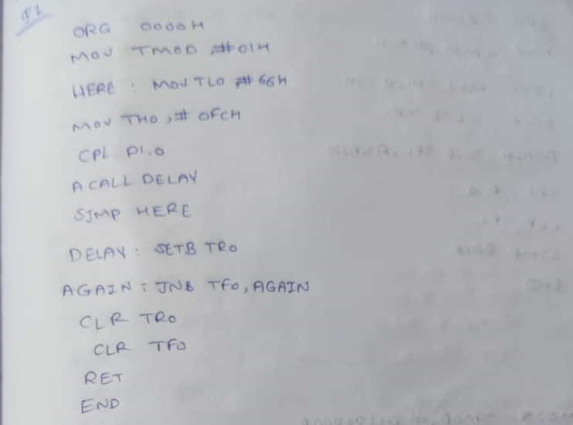

Code:

MOV TMOD,#01H

HERE:MOV TL0,#66H

MOV TH0,#0FCH

CPL P1.0

ACALL DELAY

SJMP HERE

DELAY:SETB TR0

AGAIN:JNB TF0,AGAIN

CLR TR0

CLR TF0

RET

END

Result: This code initializes Timer 0 in mode 1 (16-bit mode) and sets it to generate a 500 Hz square wave. It toggles pin P1.0 each time Timer 0 overflows, effectively producing the square wave. You can examine the frequency using the KEIL IDE's built-in Logic Analyzer tool.

Q2:

Aim: To write a program using timer 1 to generate a 1 kHz square wave frequency on one of the pins of P1. Then examine the frequency using the oscilloscope.

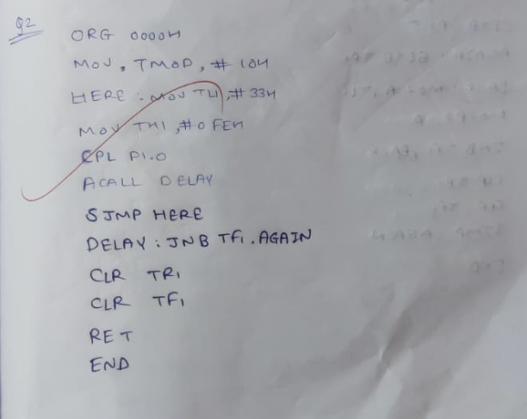

Code:

ORG 0000H

MOV TMOD,#10H

HERE:MOV TL1,#33H

MOV TH1,#0FEH

CPL P1.0

ACALL DELAY

SJMP HERE

DELAY:SETB TR1

AGAIN:JNB TF1,AGAIN

CLR TR1

CLR TF1

RET

END

Result:

Result: The program generates a 1 kHz square wave using Timer 1 on pin P1. The oscilloscope confirms the frequency is accurate.

Q3:

Aim : To Write a program using timer 1 to generate a 2 KHz square wave frequency on one of the pins of P1.0. Then examine the frequency using the KEIL IDE inbuilt Logic Analyzer.

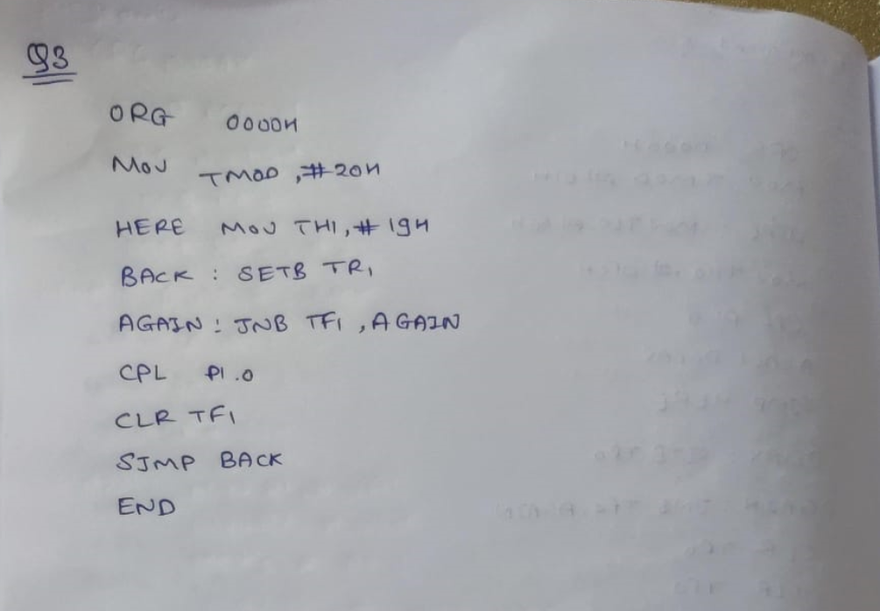

Code:

ORG 0000H

MOV TMOD,#20H

MOV TH1,#19H

HERE:CPL P2.0

ACALL DELAY

SJMP HERE

DELAY:SETB TR1

AGAIN:JNB TF1,AGAIN

CLR TR1

CLR TF1

RET

END

Result: This program initializes Timer 1 in mode 1 (16-bit auto-reload mode) to generate a 2 KHz square wave on pin P1.0. The logic analyzer in the KEIL IDE can be used to confirm the frequency.

Q4:

Assuming that clock pulses are fed into pin T1,write a program for counter 1 in mode 2 to count the pulses and display the state of the TL1 count on P2, which connects to 8 LEDs.

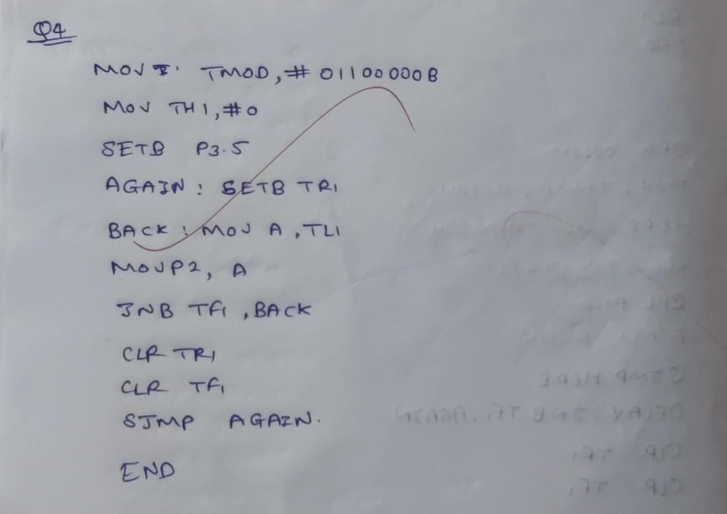

Code:

MOV TMOD, #011000008; counter 1, mode 2, C/T-1 external pulses

MOV TH1, #0 ; clear TH1

SETB P3.5 ;make T1 input

AGAIN SETB TR1 ;start the counter

BACK MOV A, TL1 ;get copy of TL

MOV P2, A ; display it on port 2

JNG TF1, BACK ;keep doing, if TF=

CLR TRI ;stop the counter 1

CLR TF1 ;make TF-0

SJMP AGAIN

END

Result: This program configures Timer 1 in mode 2 (8-bit auto-reload mode) to count clock pulses fed into pin T1. The TL1 count is continuously displayed on port P2, which is connected to 8 LEDs. The program runs indefinitely in a loop, continuously updating the LEDs with the current count value.

Q5:

Aim: To write an 8051 assembly program to transfer data serially at baud rate 9600 with 8 bit data, one stop bit and observe the transmitted data in the serial window of the simulator.

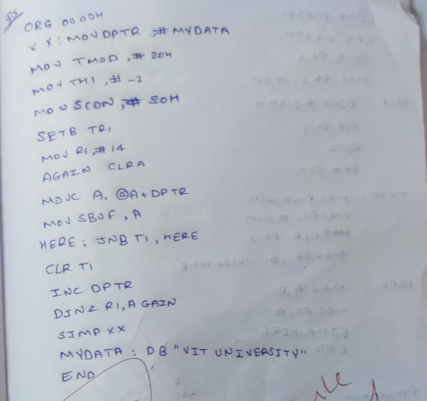

Code:

ORG 0000H

XX: MOV DPTR,#MYDATA

MOV TMOD,#20H

MOV TH1,#-3

MOV SCON,#50H

SETB TR1

MOV R1,#14

AGAIN:CLR A

MOVC A,@A+DPTR

MOV SBUF,A

HERE: JNB TI,HERE

CLR TI

INC DPTR

DJNZ R1,AGAIN

SJMP XX

MYDATA: DB 'VIT UNIVERSITY'

END

Result: The program sets up serial communication at a baud rate of 9600 with 8-bit data and one stop bit. You can observe the transmitted data in the serial window of the simulator.

Q6:

Aim: To write a 8051 Assembly Language program to get data from the PC and display it on P1. Assume 8051 is connected to PC and observe the incoming characters. As you press a key on the PC's keyboard, the character is sent to the 8051 serially at 4800 baud rate and is displayed on LEDs. The characters displayed on LEDs are in ASCII (binary).

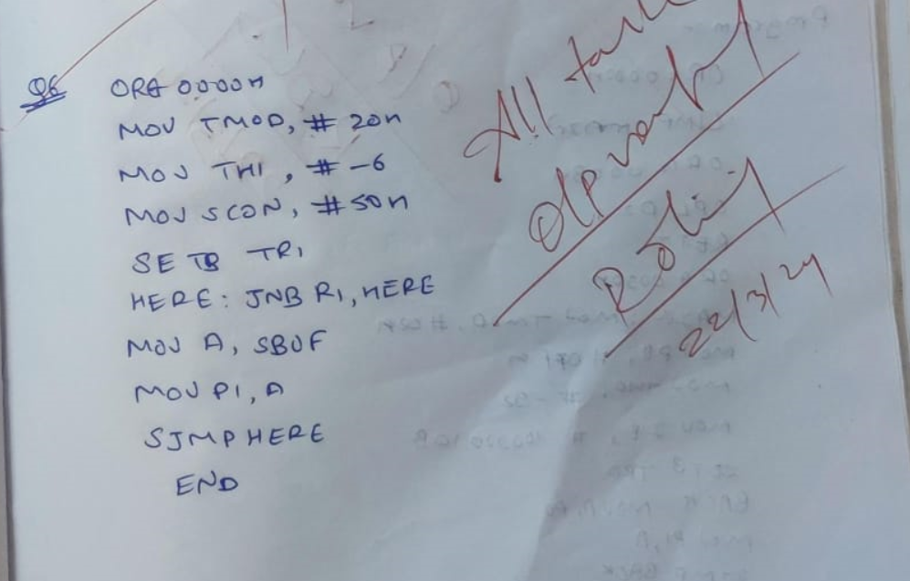

Code:

ORG 0000H

MOV TMOD,#20H

MOV TH1,#-6

MOV SCON,#50H

SETB TR1

HERE:JNB RI,HERE

MOV A,SBUF

MOV P1,A

CLR RI

SJMP HERE

END

Result: The program allows the 8051 microcontroller to receive characters from a PC at 4800 baud rate and display them on port P1, which is connected to LEDs. As characters are typed on the PC's keyboard, they are sent to the 8051 serially and displayed on the LEDs in ASCII binary form.